Height Manager

Height Manager is a simple application to add and save students’ body height. The application has three main menus, they are:

1. Add New Height
2. Print All Height
3. Exit

Main Menu

You must use array of struct to store data in the application. You need to design your own struct. Your task is to create this application in C Programming language based on the following requirements:

1. Menu 1 – Add New Height

User can access this menu to start adding a new height. When the user chooses this menu:

* The program will ask the user to input NIM. The input must be 10 numeric characters
* The program will do update if the inputted NIM already exists
* The program will ask the user to input height’s foot. The input must be between 0 and 7 (inclusive)
* The program will ask the user to input height’s inch. The input must be between 0 and 11 (inclusive)
* Calculate the height in cm: 1 foot = 12-inch, 1 inch = 2.54 cm, save the calculated cm in a decimal variable in the struct.
* The program will display success message and keep inserted/updated height to the array of struct
* Data is automatically sorted by height (in cm) (ascending) in every input, if there are data with same height (in cm), then sort by NIM (ascending)

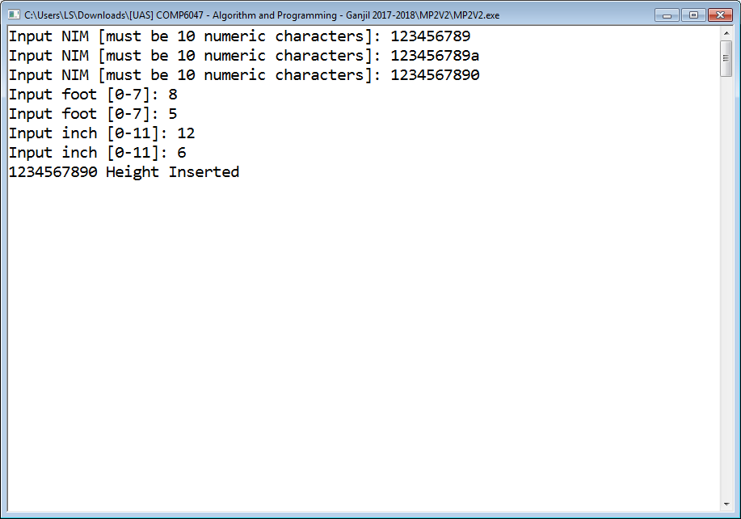

Add New Height

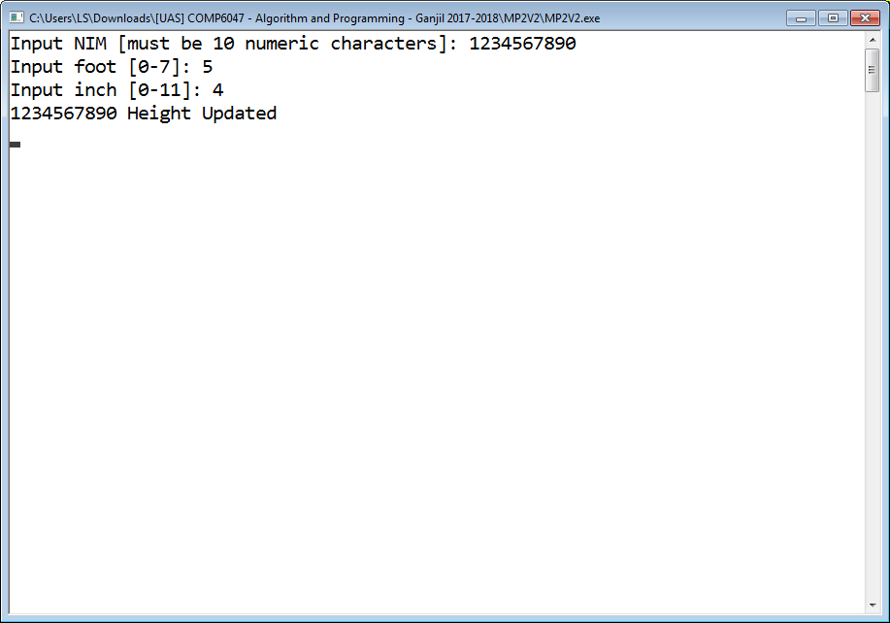

Update Height

1. Menu 2 – Print All Attendance

User can access this menu to view all attendance records with [NIM] [foot]’[inch]” [height in cm]cm format. Print “No data” if there is no data inserted yet.

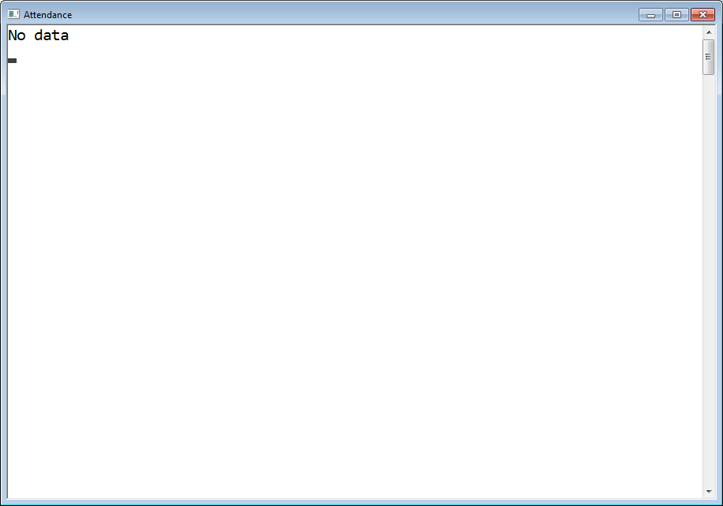

Print All Height Menu – No data inserted

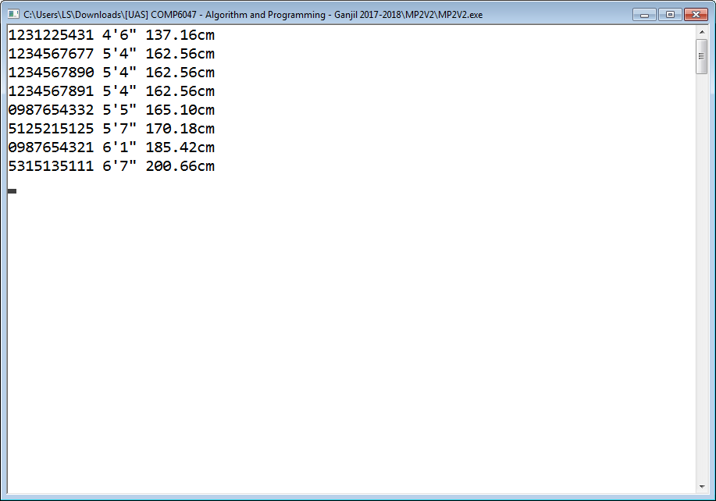

Print All Height Menu

1. Menu 3 - Exit

User can access this menu to exit from the application

-- Selamat Mengerjakan --